**Level 1**

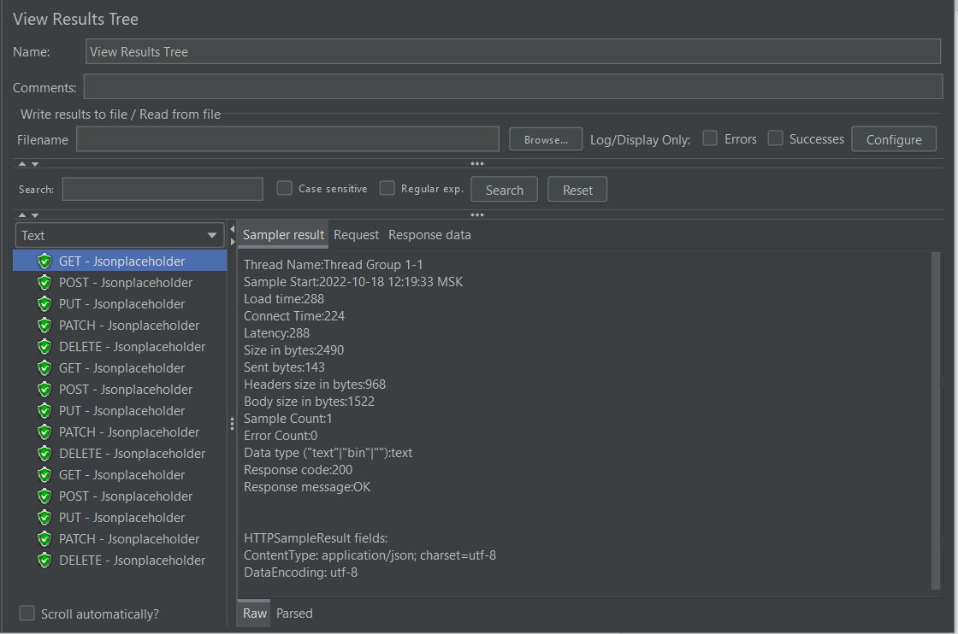

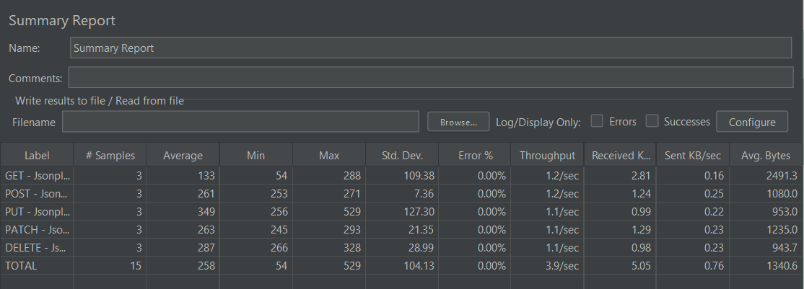

Notes: All tests were done successfully, according to settled assets: response, size, duration of assertion. The test is done within 3 sec. (3 loop counts), and not required 10 sec.

**Level 2**

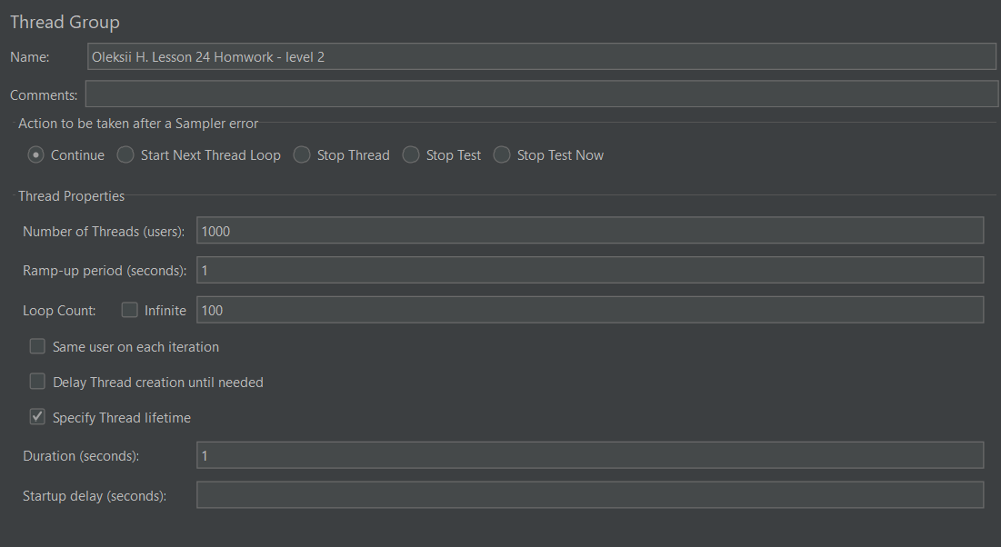

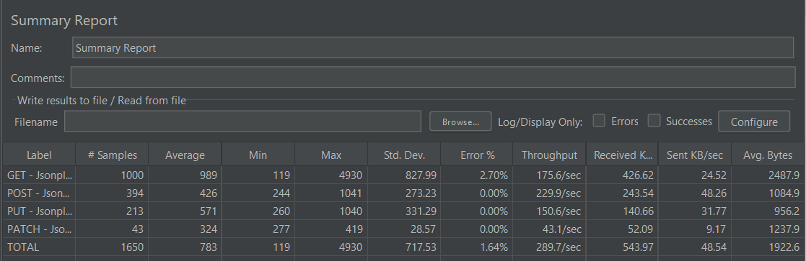

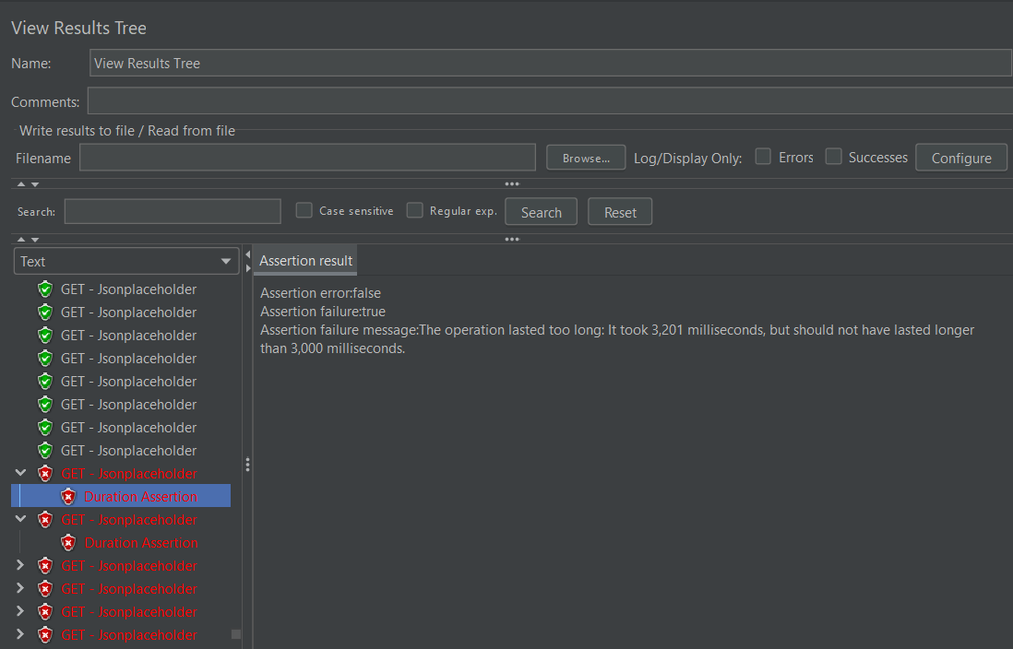

Notes: With current parameters in thread tests are dropping according to settled duration asserts - overlimiting. As a result, rest requests cannot be accomplished.

Also was tested for next parameters:

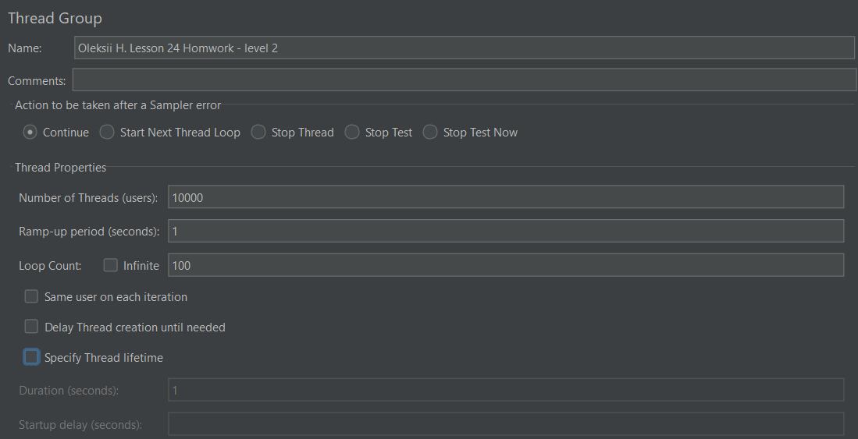

System was overloaded, with next results: Mostly errors are occured

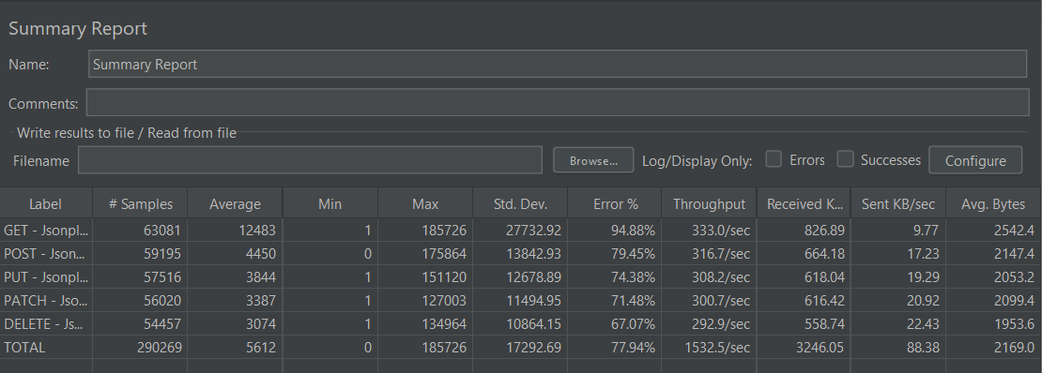

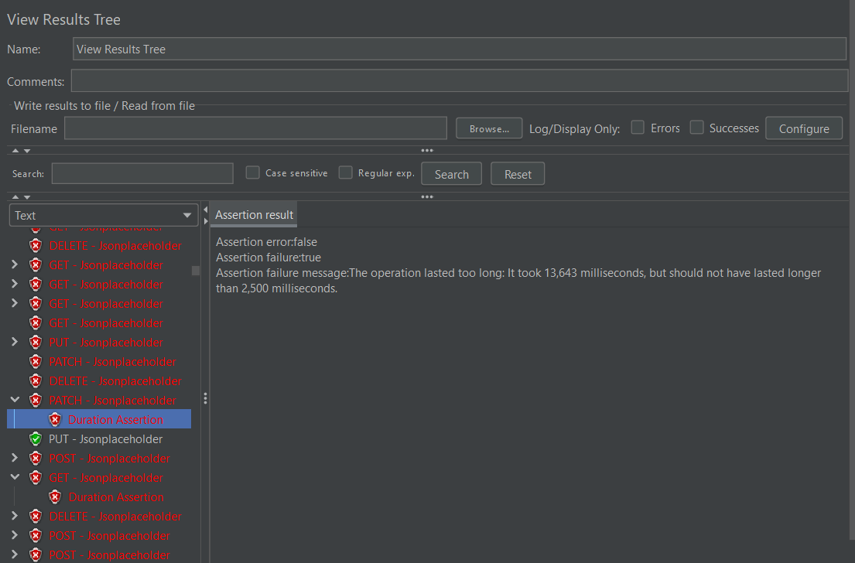

**Level 3**

Cmd line:

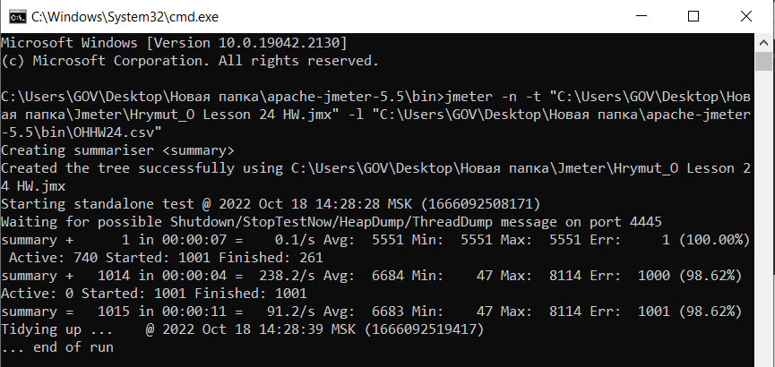

Csv file:

